

CAPSTONE PROJECT 2

PROPOSAL DOCUMENT
Help Find Lost Loved Ones
CODE: PROPOSAL_v1.0
Date : Feb-28, 2023

Submitted by
Vu, Truong Quang
Vinh, Tong Tran
Nhan, Tran Van
Thien, Le Van
Luan, Nguyen Thanh

Approved by Mentor
Thuan, Nguyen Tan Ph.D

Name Signature Date

INTERNATIONAL SCHOOL OF DUY TAN UNIVERSITY
Project Information
Project acronym | FLR
Project Title | Find Lost Relatives
Start Date | 28 Feb 2023 | End Date | 20 May 2023
Lead Institution | International School, Duy Tan University
Project Mentor | Thuan Nguyen Tan, Ph.D.
Project Manager & contact details | Vu, Truong Quang  Email:truongquangvuu09@gmail.com;  Tel: 0862657805
Partner Organization
Project Web URL
Team members | Name | Email | Tel
 | Vinh, Tong Tran | tongvinh.98.1906@gmail.com | 0985771298
 | Nhan, Tran Van | tranvannhan2362001@gmail.com | 0772019581
 | Thien, Le Van | thienpro1499001@gmail.com | 0965382571
 | Luan, Nguyen Thanh | luanthanh.16082000@gmail,com | 0765432410

Proposal Document

Document Title | Proposal
Reporting Period | Feb 2023
Author(s) & project | Vu Truong Quang, Project Manager
Role | Vinh, Tong Tran | Member
 | Nhan, Tran Van | Member
 | Thien, Le Van | Member
 | Luan,Nguyen Thanh | Member
Date | 28 February 2023 | Filename | Proposal_v1.0
URL
Access | Project and CMU Program

Document History
Version | Date | Comments
V1.0 | 28 Feb 2023 | Draft for comment

Document Approvals: The following signatures are required for approval of this document.
Thuan, Nguyen Tan, Ph.D  Mentor |  | Date
Vu, Truong Quang  Project manager |  | Date

_{Table of Contents}
1. Introduction 1
1.1. Purpose 1
1.2. Scope 1
1.3. References 1
2. Project Overview 2
2.1 Project definition 2
2.2 Business needs/ User needs 2
2.3 Prior Art: 4
2.4 Proposed Solution 4
2.4.1 Project goal 4
2.4.2 System overview 6
2.4.2.1 System context 6
2.4.2.2 System context description 6
2.4.3 Technical Constraints 7
3. Master Plan 8
3.1 Scrum Process 8
3.2 Master plan 9
3.3 Organization Management 9
3.3.1 Human Resource 9
3.3.2 Cost Estimation 10

Introduction

Purpose
The purpose of the proposal is to:
- Find Lost Relatives puts you in contact with family members you may have never met, never knew existed or never thought you’d see again.
- When you feel the time is right, we’ll trace whoever you’re looking for and give you the emotional support you need to finally fill that hole in your life.
- Maybe it’s a parent who you haven’t seen since you were a child. Or a sibling that disappeared without a word more than a decade ago. It could even be an auntie that you lost touch with in the last couple of years. Whatever your situation, and whoever you’re looking for, perhaps you’ve got the feeling that things aren’t quite right. And you’re considering finding them so you can reach out and make things better. Every situation is different, but there’s something that stays the same in every story… When you know someone’s missing, you get that nagging feeling of wanting to find them. Because how are you supposed to deal with the fact that a family member is out there living life without you? When the table feels that little bit emptier every birthday or New Years?
- Currently, You go through phases where it’s fine and you carry on as normal. But then you can get that familiar feeling of sadness – like you’re lost – which hits you time after time. When you try to repress the feelings, do you notice that they nearly always rear their head again? And even if you’re unsure about getting in touch or you don’t think it’s the right time.
- Unfortunately, life sometimes gets in the way of our plans. The sooner you try to make contact, the more likely it is that your family member is out there waiting for your call.
- Although it may take time to build up the courage you need to take the first step – that’s okay. After all, this could be one of the biggest decisions you ever make in your life. We’ll be here whenever you’re ready.
- The above statements make it clear to us that if you’re curious about how you can take the first step, we can jump on a call, learn a bit more about your story, talk you through your options and find out whether we can help you get in contact with the person you’re looking for.

Scope
- This document provides an overview of how the project will be developed. It includes a product overview, a process overview, and a project team overview.
- In addition, this project is being supervised by the university environment and it is carried out with limited cost and time. So the goal of this project is to be released with all the basic functionality outlined from the start.
- Through the project, conflicts between team members, problems occurring during the development phase, will be a great contribution for all members in learning and developing technical skills. such as coding, testing, design.

Project Overview

Project definition
some people have lost their relatives ones, and they wish to find their relatives ones again, long lost people have a desire to find their own family and relatives, but there is no such thing conditions to be able to search directly
Realizing those difficulties and inconveniences, we decided to build a website to help them find their lost relatives ones easier and less expensive.

Business needs/ User needs
Family is the most important thing in a person's life, but there are unlucky people who lost their children, wife, husband, parents a long time ago, since they were young. and now they want to find their relatives again, but they lost their relatives at a very young age
It is very difficult for them to start a search on their own if they go through the media it will cost a lot of money, but if they go directly to find it, it takes a lot of time and effort as well as a lot of money. is money invested to maintain the search for a longer time, but it is not certain that they will be able to find their loved ones, to solve the above problems we want to create a website to help them find their loved ones. You can find your loved one with less effort and expense, no need to spend time and effort to find them, just go to the website to leave your personal information, and your information. the people they need to find again, with the help of the website participants, they can find their loved ones with less money and effort

Prior Art:
Up till now, there are few websites which has use to find lost relatives, but the information is inadequacy and very difficult to find, to use it.
Example:
- http://timnguoithatlac.vn/
 | Find Lost Relatives | timnguoithatlac
Comment for Post | x
Donation Program | x
Chat online | x
DNA bank |  | x

Proposed Solution
Our team recommends building a website “Finding Lost Relatives” with full features for users: Post and Find information about people to look for. With this feature, users can find out about lost relatives ones more easily.
Our team based on the requirements and come up with solutions and project implementation.
This software is designed for users who have lost their loved ones and want to find them again

Project goal
The goal of project is to build the “Find Lost Relatives” app with more functions that meet customer needs within budget and schedule successfully:
- Register to find relatives
- See the list of people looking for relatives
- See news about lost people
- Update the information of the person looking for
- See the list of lost people by situation
- Find lost people by name, birth year, hometown

System overview

System context
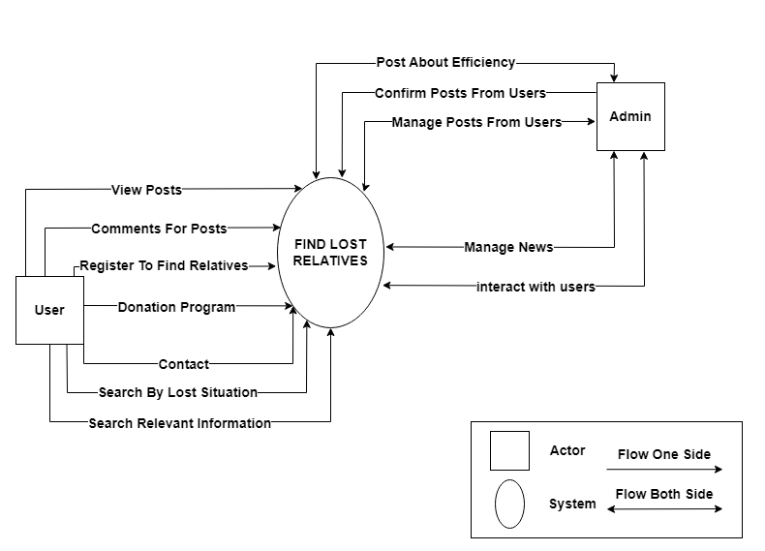
Figure 2.6.1: System context overview

System context description
Admin will be a team member, has a responsibilities to manager the system.
User will use the application with three main functions:
- Find people according to identification information:
            - The program will provide articles with information related to the search content
- Posting content to be searched :
            - Users can post their important identification information.
- Search according to lost circumstances:
            - The program also provides search and search function in the situation when lost as abandoned, left home, war ....

Technical Constrains
Technicals for Building Project
Technical to develop
- Language: Java Script, HTML5, CSS3, ReactJS, NodeJS
- Operating system: Microsoft Windows
- Develop tool: Visual Studio Code
- Database Management System: MySQL, MongoDB
- Version Control System: Github
Environment
- Tool: Visual Studio Code
- Operation systems: Microsoft Windows
Business constraints
- Resource: 5 people.
- Budget: 2000$.
- Time: The project must be completed within 3 months.

Master Plan

Scrum Process

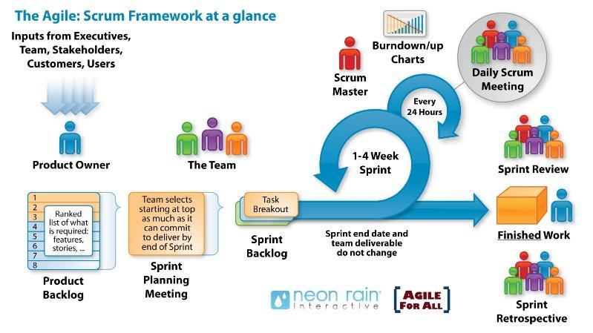
Figure: General SCRUM Process
- Scrum is an iterative and incremental agile software development framework for managing software projects and product or application development.
- Scrum focuses on project management institutions where it is difficult to plan ahead.
- Mechanisms of empirical process control, where feedback loops that constitute the core management technique are used as opposed to traditional command-and-control management.
- Its approach to planning and managing projects is by bringing decision-making authority to the level of operation properties and certainties.

Master plan

NO | Task Name | Duration | Start | Finish
1 | Start Up | 14 days | 26/02/23 | 12/03/23
1.1 | Project Kick Off Meeting | 1 day | 26/02/23 | 26/02/23
1.2 | Discuss about project ideal | 3 days | 27/02/23 | 1/03/23
1.3 | Create Document for project | 10 day | 2/03/23 | 12/03/23
2 | Development | 65 days | 13/03/23 | 15/05/23
2.1 | Sprint 0 | 5 days | 13/03/23 | 17/03/23
2.2 | Sprint 1 | 25 days | 18/03/23 | 09/04/23
2.3 | Sprint 2 | 25 days | 10/04/23 | 04/05/23
2.4 | Sprint 3 | 10 days | 05/04/23 | 15/05/23
3 | Project’s Meeting | 1 days | 16/05/23 | 16/05/23
4 | Final Release | 3 days | 17/05/23 | 19/03/23

Organization Management

Human Resource
- Team’s Information
Full Name | Phone | Email | Position
Ph.D Nguyen Tan Thuan |  | thuannt.it.dtu@gmail.com | Mentor
Truong Quang Vu | 08652657805 | truongquangvuu09@gmail.com | Team Leader
Tong Tran Vinh | 0985771298 | tongvinh.98.1906@gmail.com | Team Member
Le Van Thien | 0965382571 | thienpro14990011@gmail.com | Team Member
Nguyen Thanh Luan | 0765432410 | luanthanh.16082000@gmail.com | Team Member
Tran Van Nhan | 0772015981 | tranvannhan2362001@gmai.com | Team Member

Cost Estimation
The following outlines the cost to complete all the identified components for the project.
No. | Phase | Milestone | Cost( 2 hours/day)  USD
1. | Start-up | STU | $200
2. | Development | SPR 0 | $25
2. | Development | SPR1 | $150
2. | Development | SPR2 | $155
2. | Development | SPR3 | $70
3. | Other costs | OTH | $600
4. | Project’s Meeting | PM | $5
5. | Final Release | FR | $20
6. | Total |  | $1.225

Project Constraints

Constraint | Constraints Description | Guidelines for Acceptance
Economic | Building the website itself takes up most of the project's cost, the project needs to have the server to store resources and operate the system. However, it is necessary to ensure that renting a server must have the lowest possible price while still meeting the requirements and purposes of use. Other costs involved in the project are system maintenance, system improvement and system administrator costs. | Elements for consideration are design costs, production costs, maintenance costs, operating costs, and sales price
Environmental | The design has no impact on the environment.In contrast, environmental factors do not affect the design of the project. The design of the project uses energy sources and environmentally friendly materials | The impact of the design on the environment as well as the impact of the environment (e.g. temperature range, humidity, vibration, electromagnetic interference immunity, and shock) on the design should be considered. Design for recycling and design to use recycled materials should also be considered
Ethical | The project will aggregate resources that have been shared in the community and use open-source documents. In addition, improve security and encrypt data sources collected from users to protect and avoid being used for wrong purposes(e.g. information theft, unauthorized purchase and sale..) | Ethical considerations can be broad. Areas that are typically addressed include intellectual property, reverse- engineering, privacy, security, and the conflict between cost and safety
Public health, safety, and welfare | My website support the work of the global public health community to keep people safe and community welfare including safety standards. We’re also working to address the long-term impacts by supporting industries in need and making it easier for people to find and offer help in their communities. | Includes safety standards as well as the impact of the design on users (for example, electrical or physical hazards)
_{Social and Global} | Applying the project to the community according to social policies to meet the interests for users and avoid risks. Meet the needs of users, ensure their rights and help them, make society better | Addresses aspects such as benefits, risks, the man-machine interface, the acceptance of products by the intended user or by society at large, and global and socially responsible engineering.
Cultural | No content that promotes religion or racist.  Posting or sharing of illegal content is not allowed  No comments or posts that are offensive or have inappropriate language | Which cultural characteristics could influence the approach?  How do the design from different cultures differ?
Sustainability | The project development team consists of 4 fixed members with a fixed time frame (8 hours/day and 56 hours/week) throughout 75 days to ensure the project meets the planned development timeline.  Provide routine application maintenance.  Improve application performance.  Selective data storage. | Refers to the sustainability of resources, including material, energy, supplies, manufacturing techniques, personnel, operation, and the need for additional infrastructure, as well as the sustainability of the design including reliability, lifetime, durability, reusability, maintainability.

Conclusion
Faced with the fierceness of the past, partly due to war and partly due to other subjective factors, many families had to be separated and lost loved ones due to special circumstances. So this site will be a useful tool:
- Support to find loved ones lost many years ago
- Find lost relatives according to circumstances
- View news about updated daily
- Provide clear, specific information to connect

References
No. | References | Document Information
1 | Scrum Model | https://www.atlassian.com/agile/scrum
1 | Scrum Model | https://www.digite.com/agile/scrum-methodology/
1 | Scrum Model | https://docs.microsoft.com/en-us/azure/devops/boards/sprints/b est-practices-scrum?view=azure-devops
1 | Scrum Model | https://www.scrum.org/resources/scrum-guide
2 | Technical | https://reactjs.net/getting-started/aspnetcore.html
 |  | https://reactjs.org/docs/getting-started.html#learn-react
3. |  | https://www.nws.noaa.gov/oh/hrl/developers_docs/General_So ftware_Standards.pdf
3. |  | https://standards.ieee.org/standard/12208-2017.html
3. |  | https://sw-eng.larc.nasa.gov/

Attachment: DESCRIPTION OF PRODUCT REQUIREMENTS FORM

